Decision table & checklist for authorization

Decision table for authorization (login)

Conditions | TC 1 | TC 2 | TC 3 | TC 4 | TC 5 | TC 6 | TC 7 | TC 8 | TC 9 | TC 10 | TC 11
E-mail address | Valid | Valid | Valid | Invalid | Invalid | Invalid | Empty | Empty | Empty
Password | Valid | Invalid | Empty | Valid | Invalid | Empty | Valid | Invalid | Empty | Invalid | Invalid
Forgotten Password |  |  |  |  |  |  |  |  |  | Registered email id | Unregistered email id
Actions
Authorization | Passed  Home screen  is displayed | Failed  Error message  is displayed | Failed  Error message  is displayed | Failed  Error message  Is displayed | Failed  Error message  is displayed | Failed  Error message  is displayed | Failed  Error  message  is displayed | Failed  Error message  is displayed | Failed  Error  message  is displayed
Reset  the new password |  |  |  |  |  |  |  |  |  | Yes | No

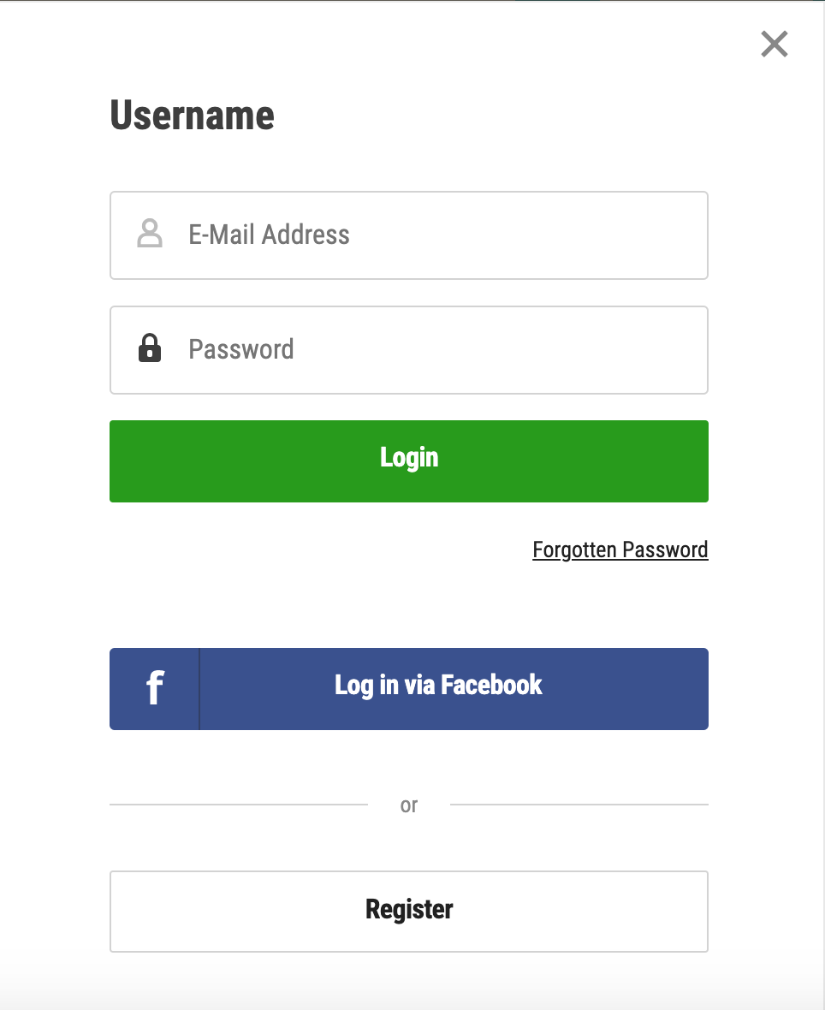

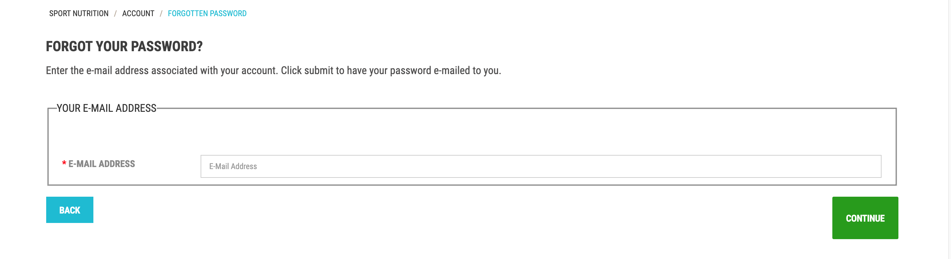

Checklist

Nr. | Checking | Expected result
1 | Enter a valid e-mail address and valid password and click on login. | The login is succussed. Home screen is displayed.
2 | Enter a valid e-mail address and an invalid password and click on login. | The login is not succussed. The system displays error message.
3 | Enter a valid e-mail address and empty field password and click on login.
4 | Enter an invalid e-mail address and a valid password and click on login.
5 | Enter an invalid e-mail address and invalid password and click on login.  .
6 | Enter invalid e-mail address and valid password and click on login.
7 | Enter e-mail address and password are left blank and click on login.
8 | Enter e-mail address is left and invalid password and click on login.
9 | Enter valid e-mail address and password is left blank and click on login.
10 | Enter registered email id address and click on continue button. | User should get the new password on his/her email address.
11 | Enter unregistered email id and address and click on continue button. | The system displays error message.

